1 Practical Exam for 2026 Spring – Page 02
Subject Code | SBA301
Subject Name | Integrate single page application with Spring Boot
Time | 90 minutes (include submit time)
Exam Type | PE Practical Exam
Note
a) Allow student to connect to Internet within 10 minutes when setting up project at the beginning examination
b) Student can only use resources in local computer

2 Exam Requirements
Project Code | IMS
Develop the following pages in ReactJS (latest version) and React-Bootstrap using axios to connect with provided RESTful API run on Spring Boot.

2.1 Screen Layout & Requirements

2.1.1 Screen Layout of Ingredient List

Logo |  |  |  | Inventory Management
 |  |  |  |  |  |  |  |  |  |  |  |  |  |  | Date: yyyy-MM-dd
 | Ingredient List
 |  | Category:
 |  |  |  |  |  |  |  |  |  |  |  |  | Filter |  | Add New
 | Ingredient Name:
 | Ingredient List
 | # | Ingredient Name |  |  |  |  | Category | Producer |  |  | Supplier |  | Price range(đ) |  | Action
 | 1 | Fresh milk |  |  |  |  | Fresh Food | Hoang |  |  | Hang Bai |  | 1000-20000 | Delete | View
 | Show x of y records |  |  |  |  |  |  |  |  |  |  |  | Previous 1, 2, 3 …. Next
@ 2026 FU University
Screen 1: List Screen

 |  |  |  |  | Confirmation
 |  | Are you sure you want to delete the ingredient "Fresh milk"?
 |  |  |  |  | Yes |  |  |  |  | Close
 |  | Screen 2: Confirmation Screen

Screen Definition
# | Field name |  | Mandatory | Length | Description |  |  | Type
1 | Ingredient Name |  | Yes | 100 |  |  |  | Text box
2 | Category |  | Yes | NA | It is the list got from API |  |  | Dropdown
3 | Ingredient List |  | Yes |  | Display the list of Ingredient matched with filter conditions
4 | Add New |  |  | NA |  |  |  | Button
5 | Filter |  |  | NA |  |  |  | Button
6 | View |  |  | NA | Go to “View Details“ page |  |  | Hyperlink
7 | Delete |  |  | NA | Delete the Ingredient on the row |  |  | Hyperlink

Item |  | Mark
1. Functional Requirements |  | 3.5
1 | a) When the user go to the page, all Ingredients in the database will be displayed in the list.  b) When the user enter filter conditions and click filter buttons, the software will query data and display the result matching with search condition  c) The filter result need to have pagination if the list has >1 pages.  d) When user clicks on “Previous/Next” the software will display the previous/next page of the filter result. If user clicks on the number of the page list, the software will display the records of that page  e) If there is no result, the message “No records found” is displayed in the result list  f) The filter result is ordered by Ingredient name ascending  g) Pagination info is not shown when the filter result has only one page
2 | When the user click on “Add New” button on the “Ingredient List”, the software will display the “Add New Ingredient” screen.
3 | When the user click on “Delete” button on the row of the Ingredient list , the software will show a confirmation dialog  a) If user select “Yes” option, the software will  - call API to delete the Ingredient from database  - show the message (Message ID = MS08) on the screen  - and call API to update the Ingredient list  b) If user select “Close”, the software close the dialog
4 | When the user clicks on “View”, the software will display the “View Details” page contain the detail information
5 | If there is an error occurred when calling API, the software display error message (Message ID =MS05) on the screen
2. Non-functional requirements |  | 0.5

2.1.2 Screen Layout of Ingredient Details

Logo |  | Inventory Management |  |  |  |  |  |  |  |  |  |  |  |  |  |  |  |  |  |  |  |  |  |  |  |  |  |  |  |  |  | Date: yyyy-MM-dd
 |  | VIEW DETAILS
 |  | Ingredient Name: |  |  |  |  |  | Fresh milk
 |  | Producer name: |  |  |  |  |  | Masan company
 |  | Category: |  |  |  |  |  | Fresh Food
 |  | Price range (đ): |  |  |  |  |  | 10000 – 20000
 |  | Supplier: |  |  |  |  |  | FPT Company
 |  | Entry Date: |  |  |  |  |  | 2025-01-25
 |  |  |  |  |  |  |  | Quay Lai
 |  | @2026 FPT University
Screen 3: Detail Screen
Items | Mark
1. Functional Requirements | 1.0
2. Non-functional requirements | 0.5

2.1.3 Screen Layout of Add New Ingredient
Logo |  | Inventory Management |  |  |  |  |  |  |  | Date: yyyy-MM-dd
 | Add New Ingredient
 |  |  |  | Ingredient name:
 |  |  |  |  |  |  | 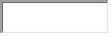
 |  |  |  |   Price from (đ): |  |  | To:
 |  |  |  | Supplier:
 |  |  |  | Producer name:
 |  |  |  | Category: |  |  |  |  |  |  | 
 |  |  |  |  |  |  | Entry Date (yyyy-MM-dd):
 |  |  |  |  | Save |  | Back
@2026 FPT University
Screen 4: Add New Ingredient
Screen Definition
# | Field name |  | Mandatory | Length | Description |  |  |  | Type
1 | Ingredient Name |  | Yes | 100 | No duplicate |  |  |  | Textbox
2 | Price from |  | Yes | 7 | The integer number, greater than 1000 and less than <1000000 |  |  |  | Textbox
3 | Price to |  | Yes | 7 | The integer number, greater than 1000 and less than <1000000. This value must be greater than “Price from” |  |  |  | Textbox
4 | Producer name |  | Yes | 100 |  |  |  |  | Textbox
5 | Entry Date |  | Yes | 10 | Format yyyy-MM-dd and not a future date |  |  |  | Date
6 | Supplier |  | Yes | 100 |  |  |  |  | Textbox
7 | Category |  | Yes | NA | It is one in the list get from API |  |  |  | Dropdown
8 | Save |  |  | NA |  |  |  |  | Button
9 | Back |  |  | NA | Go to “Ingredient List“ page |  |  |  | Button

Items |  | Mark
1. Functional Requirements |  | 3.5
1.1 | When user enter data, and then click on “Save” button, the software will  a. Validate the input data as requirements in screen definition,  b. Call API to store data,  c. and show the message (Message ID = MS04)  In case, the input data is invalid, the system will show the detailed error message.
1.2 | When the user clicks on “Back” button, the software will display the Ingredient List screen. The page is displayed same with the page when the user goes to the app
2. Non-functional requirements |  | 0.5

2.2 User interface and coding convention
User interface Requirements & Coding convention |  | Note
1 | Screen must have layout as described in Screen Layout section
2 | Item label must follow the description in Screen Layout section
3 | Graphical design must be clear, high contrast and understandable
4 | The error message must follow the rules:  a. The validation error message is shown below the field that has incorrect input  b. The system error/the successful message is shown below the screen title  c. The error message is shown in red color  d. The successful message is shown in green/blue color  e. Don’t use alert() of JavaScript to show message, use modal instead
5 | The folder, component, function, and variable name must be clear and meaningful
Message List (Error messages)
MS01 | <X> is required. | X is field name
MS02 | <X> must be greater than or equal <Y> and less than or equal <Z> | X is field name,  Y and Y is a number
MS03 | The input value is invalid format date.
MS04 | Created new ingredient successfully
MS05 | Internal system error, please contact with administrator
MS06 | The input date must be in future
MS07 | The input date must be before <Y> | <Y> is the current date + 360days
MS08 | Deleted successfully

2.3 Project structure requirements
# | Items
3.1 | The project folder must be in Visual Studio Code format and the name must following convention : <ClassName>_<StudentID>_<ProjectCode>_PE
3.2 | The project must be in React JS (latest version), React-bootstrap and using Vite, JavaScripts type run on NodeJS
3.3 | Use latest version of React JS, React-Router-DOM, React-Bootstrap, axios and Vite for the project  Note: Do not allow use other libraries
3.4 | Component name, component attributes, and functions must be named according to requirements of the application
3.5 | Please zip the project folder and then submit the zip file to EOS  Note: Follow the submit guideline in the enclosed document when submit your project
3.6 | The application must be configured to connect to REST API run at port 8080
3.7 | Path to access the application must be http://localhost:5173/
3.8 | Project folder must contain jsconfig.json file  {  "compilerOptions": {  "baseUrl": ".",  "paths": {  "*": ["../../node_modules/*"]  }  }  }
Notes:
If the provided API project gets errors, please update the API project to run the API project for developing NodeJS module. But please note all errors that you found and then enclosed with project submission

2.4 Project configuration requirements
Configuration in NodeJS server for the project must follow the convention
# | Requirements | Value
1 | Server port | 5173
2 | Server name is default | localhost
3 | Path for the application page | /

2.5 Database and URL configuration for REST API
The following URLs and database configuration for RESTful API. Please follow these configurations for use RESTful API application
- Configuration for application.properties
The following configuration can be changed to run RESTful API application if necessary
# | Items | Value
1 | Database name | SBA301_2026_PE
2 | spring.datasource.password | sa
3 | spring.datasource.username | sa
4 | Add codes for backend to allow connection from Frontend

- URL of API Description
The following table describe the RESTful API
# | Path | Method | Description
1 | http://localhost:8080/api/ingredients | GET | Get all Ingredient objects by condition
2 | http://localhost:8080/api/ingredients | POST | Create Ingredient. Return bad request status (400) if duplicated name
3 | http://localhost:8080/api/ingredients/{id} | DELETE | Delete Ingredient
4 | http://localhost:8080/api/categories | GET | Get all Ingredient category
5 | http://localhost:8080/api/ingredients/{id} | GET | Get Ingredient detail

3 Grading Policies
The following items are mandatory requirements. If one of item is violated, your result will be graded zero.
(Các mục sau là các yêu cầu bắt buộc phải tuân thủ. Nếu bài làm vi phạm một trong các mục sau, bài làm sẽ bị chấm điểm 0)
# | Item
1 | The requirements noted in the following sections:  2.3 Project structure requirements  2.4 Project configuration requirements

4 PE Submit Guideline
Please follow the following steps to delete node_modules folder in the project and then zip project sources
Step 1: Go to folder contain the project
Step 2: Open the project folder, the folder structure like below
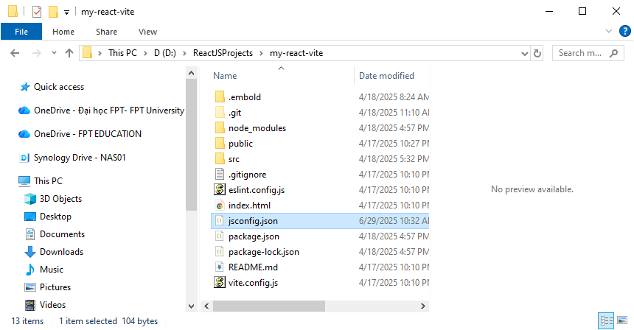
Delete this folder
Step 3: Delete “node_modules” folder
Note: Should check carefully to avoid mistakes. You should copy the project to other folder to backup before doing this task
Step 4: Go to folder that you opened in the step 1
Step 5: Right click on the project folder name and then select “send to” “Compressed (zipped) folder”

